Hello parents,

Xcel Silver States
Good Luck Gram

We are offering good luck grams for Xcel Silver States! We will have two TV’s running a good luck slide show for the gymnasts each session. If you’d like your gymnast featured on our good luck slide show, please follow the instructions below. The deadline for good luck grams is Friday, May 1st!
Step 1: Email your gymnast’s name, gym, and good luck message to climbhigh221@gmail.com
Step 2: Attach the picture you want on the slide show
Step 3: Venmo $10 to our venmo bar code below! Please make sure the gymnast’s last name and gym are in venmo caption.
***Orders are not confirmed until paid for***
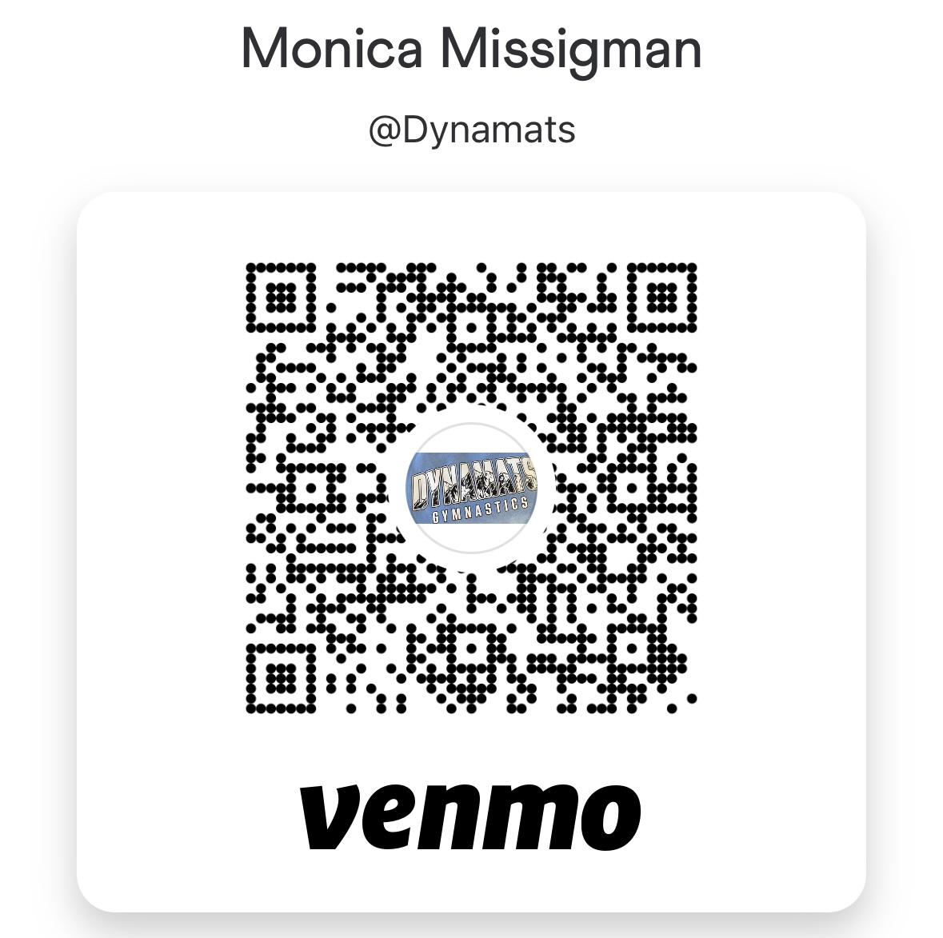

Email this form to climbhigh221@gmail.com

Gymnast Name:______________________________________________

Gym Name: __________________________________________________

Good luck message: ________________________________________________________________________________________________________________________________________________________________________________________________________________________________________________________________________________________________________________________

