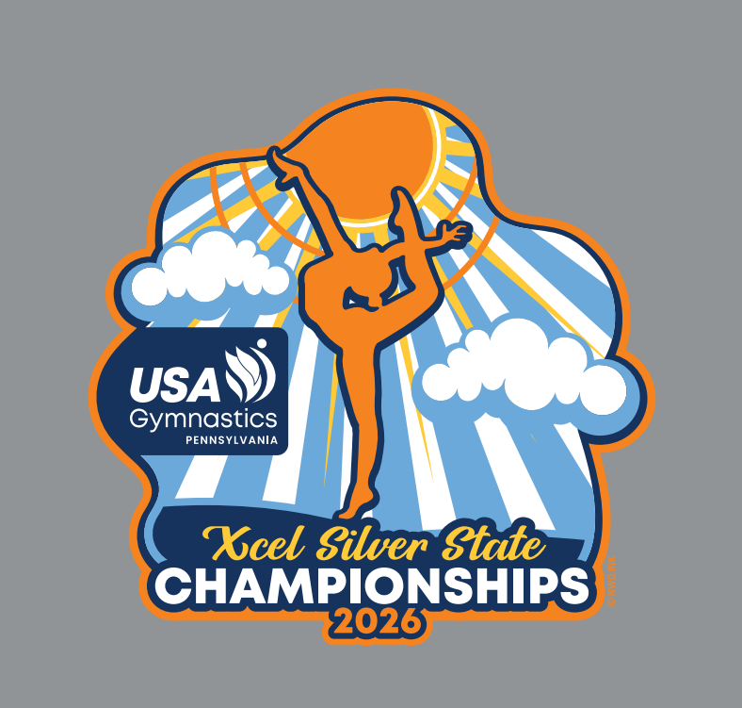

2026 Xcel Silver
State Championships
The Miller Center for Recreation & Wellness
120 Hardwood Drive
Lewisburg, PA 17837

Hosted By Dynamats Gymnastics Center
May 8th – 10th, 2026

Dynamats Gymnastic Center welcomes and congratulates your gymnasts on their qualification to the
2026 Xcel Silver State Championships! We wish you safe travels and look forward to seeing you in a few short weeks!

Host Club:
Dynamats Gymnastic Center

Competition Site:
The Miller Center for Recreation & Wellness
120 Hardwood Drive
Lewisburg, PA 17837

Meet Director:
Monica Missigman - mrf5319@gmail.com

Entries/ Registration:
All registrations must be made through USAG Reservations and Meet Maker

Qualifying Score:
The qualifying score is a 35.0

Registration Fee:
$135 per gymnast

Registration Deadline:
Friday, April 17th, 2026. Entries received after will incur a $25 late fee.

Meet Format:
Modified Capital Cup

Equipment:
AAI Equipment will be provided by Mancino Manufacturers

Awards:
Individual Event and All-Around awards will be presented to each age group at
the conclusion of each competition session. Per the Rules & Policies requirements, Placements will go out a minimum of 40% for awards. There are no team awards for Xcel Silver.

Results:
Running scores will be available near the head table. Final results will be posted
on the state website after the competition. Scores will be posted at MeestScoreOnline.com.

Coaches
Sign-In: Coaches should be pre-registered in the Meet Reservation System. Coaches will
be asked to show their USA Gymnastics Professional Member card at sign-in.
Please be sure all requirements are current: MEMBERSHIP, SAFETY CERTIFICATION, BACKGROUND CHECK and U100.
*Only professional members who are coaching and athletes competing in
the current session are allowed on the competition floor.

Session Schedule:
Will be posted at https://www.dynamats.com and on Meet Maker

Parking
Free parking lots at the front and back of The Miller Cetner

Admission:
Adults (18+) - $20
Senior/ Military Discount - $15
Children (6 to 17) - $10
Children (5 and under) - Free

Dynamats ONLY accepts CASH for admissions

Coaches Hospitality
There are a café and vending machines at The Miller Center. Dynamats will provide a snack table for coaches with grab and go snacks, drinks and coffee.

Hotels
FAIRFIELD INN & SUITES
BY MARRIOTT SELINSGROVE

6 Susquehanna Valley Mall Dr
Selinsgrove, PA 17810

570-884-8301

Cut-Off Date
March 11, 2025

COUNTRY INN & SUITES
BY RADISSON
134 Walter Drive
Lewisburg, PA 17837
570-524-6600

BEST WESTERN PLUS
COUNTRY CUPBOARD INN
7701 Westbranch Highway
Lewisburg, PA 17837
570-524-5500
Cut-Off Date
March 11, 2025

Things to do in Lewisburg
THE 15 BEST Things to Do in Lewisburg (2025) - Must-See Attractions

Places to Eat in Lewisburg
THE 10 BEST Dinner Restaurants in Lewisburg (UPDATED 2025)

T-Shirt Pre Sale Order Form

 | Gymnast Name | Size
1 |  | CM CL AS AM AL AXL A2XL A3XL
2 |  | CM CL AS AM AL AXL A2XL A3XL
3 |  | CM CL AS AM AL AXL A2XL A3XL
4 |  | CM CL AS AM AL AXL A2XL A3XL
5 |  | CM CL AS AM AL AXL A2XL A3XL
6 |  | CM CL AS AM AL AXL A2XL A3XL
7 |  | CM CL AS AM AL AXL A2XL A3XL
8 |  | CM CL AS AM AL AXL A2XL A3XL
9 |  | CM CL AS AM AL AXL A2XL A3XL
10 |  | CM CL AS AM AL AXL A2XL A3XL
11 |  | CM CL AS AM AL AXL A2XL A3XL
12 |  | CM CL AS AM AL AXL A2XL A3XL
13 |  | CM CL AS AM AL AXL A2XL A3XL
14 |  | CM CL AS AM AL AXL A2XL A3XL
15 |  | CM CL AS AM AL AXL A2XL A3XL

Size Totals: CM ___ CL ___ AS ____ AM ____ AL ____ AXL ___ A2XL____ A3XL_____
** This t-shirt will be available through pre-sale only. There will be an apparel vendor at the meet selling clothing with the meets theme on it. **
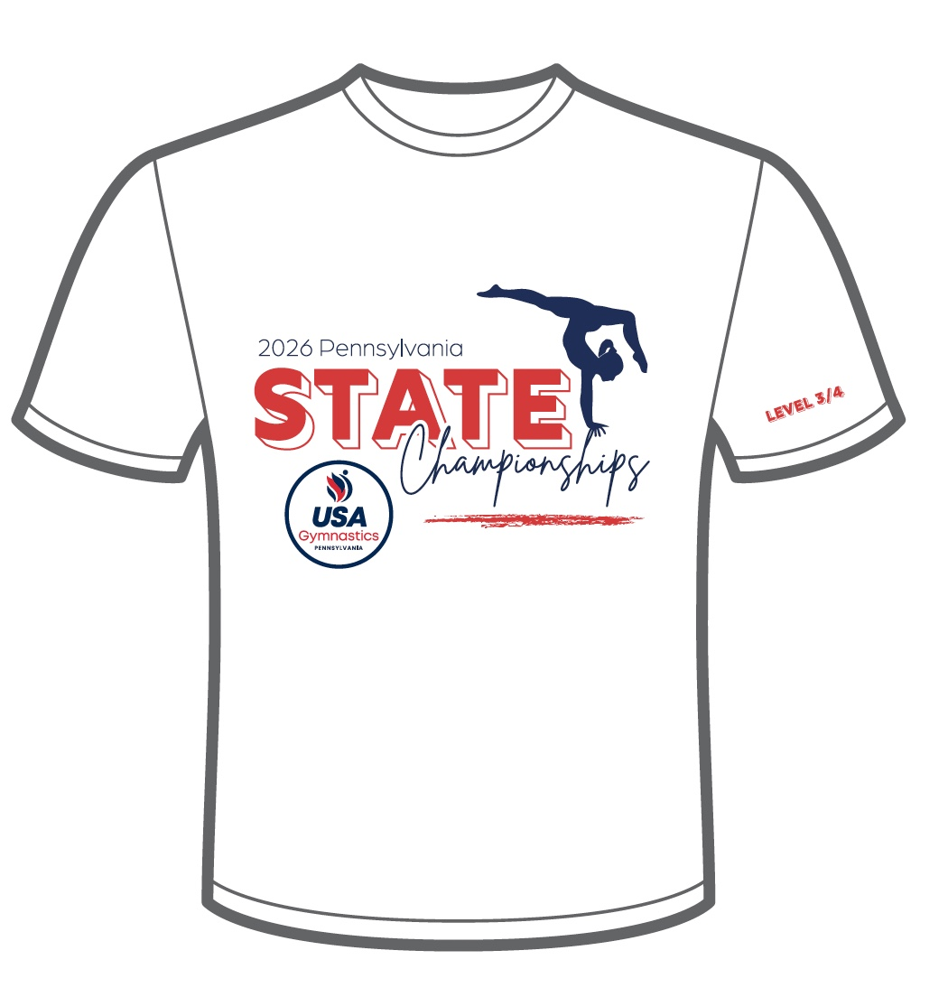
Team Name: _________________________________________________
Contact Email:___________________________
Total # of Shirts ________ x $20.00 = $__________
**Orders due by 04/19/2026. Make checks payable to Dynaparents**
Mail form and payment to
Dynamats Gymnastics Center
Attn: Monica Missigman Email form to mrf5319@gmail.com
221 Alexander Drive
Muncy, Pa 17756

Senior Bio Information
Senior Bios must be emailed to Monica Missigman at mrf5319@gmail.com by Sunday, May 26th 2026. If we do not have the completed form by this date, we may not be able to recognize them at the meet.
Gymnast Name: __________________________________________________________________________
Parents Names: __________________________________________________________________________
Club Name: ______________________________________________________________________________
Coaches: _________________________________________________________________________________
Years In Gymnastics: _____________ Favorite Event:_______________
Career Highlights: _________________________________________________________________________________________________________________________
_________________________________________________________________________________________________________________________
_________________________________________________________________________________________________________________________
________________________________________________________________________________________________________________________
________________________________________________________________________________________________________________________

Future Plans: ____________________________________________________________________________________________________
____________________________________________________________________________________________________________________
____________________________________________________________________________________________________________________
____________________________________________________________________________________________________________________

College: ____________________________________________________
Major: ______________________________________________________

